Site-to-site Between AWS to Azure

First of all I created a virtual network on Azure
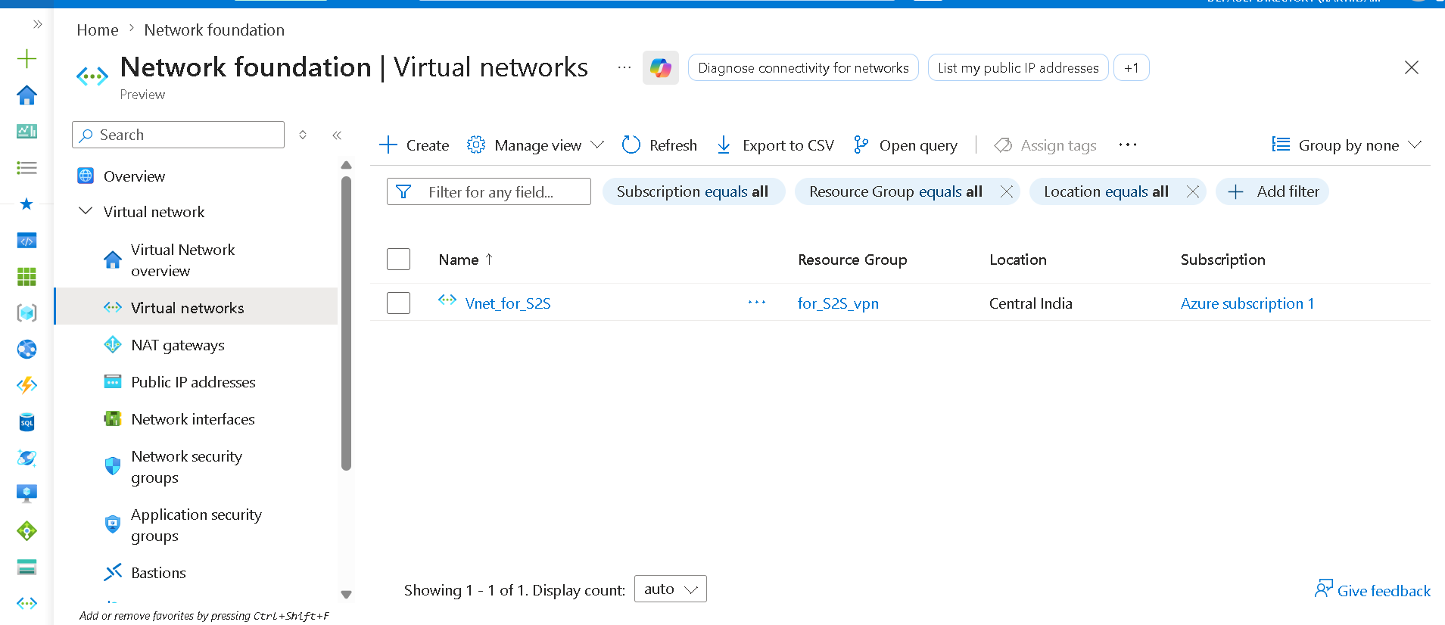

After that, I created two subnets.
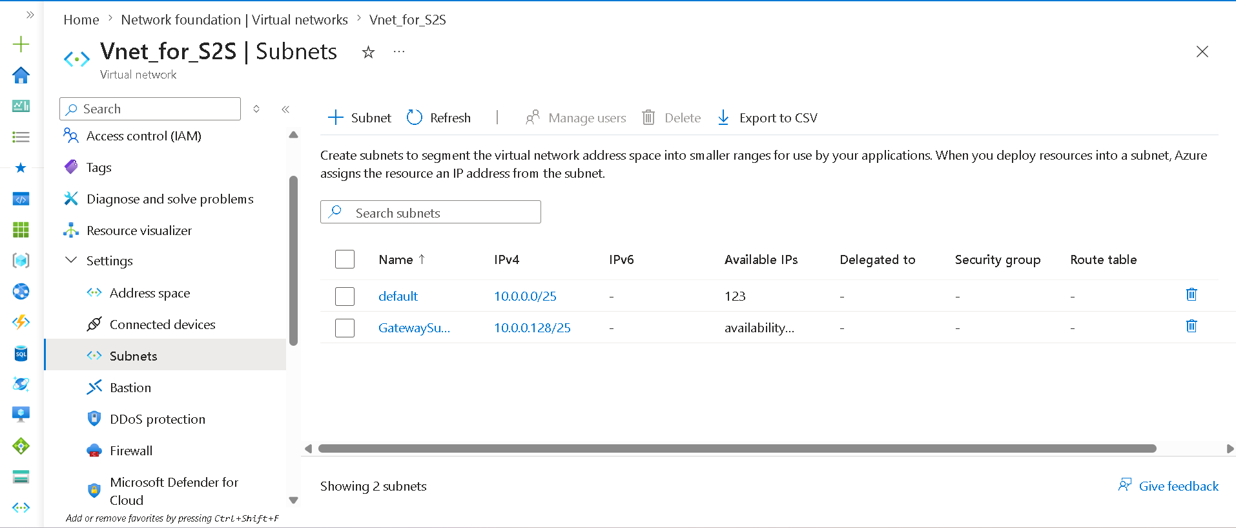
After that, I created a virtual network gateway.
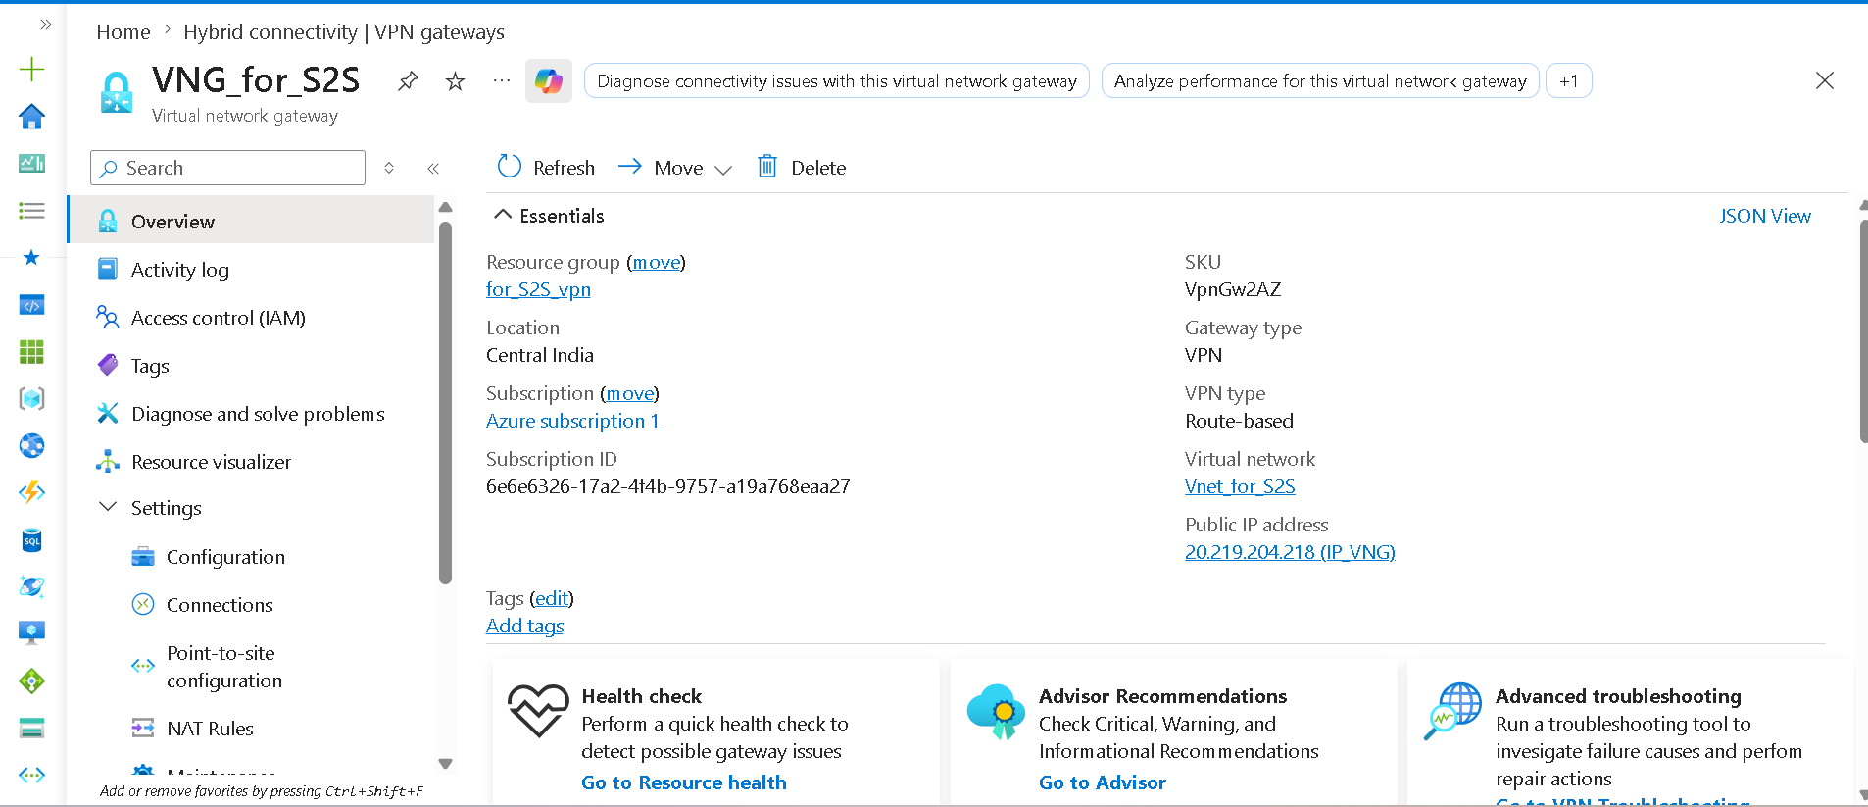

After that, I created a VPC and a subnet within it.
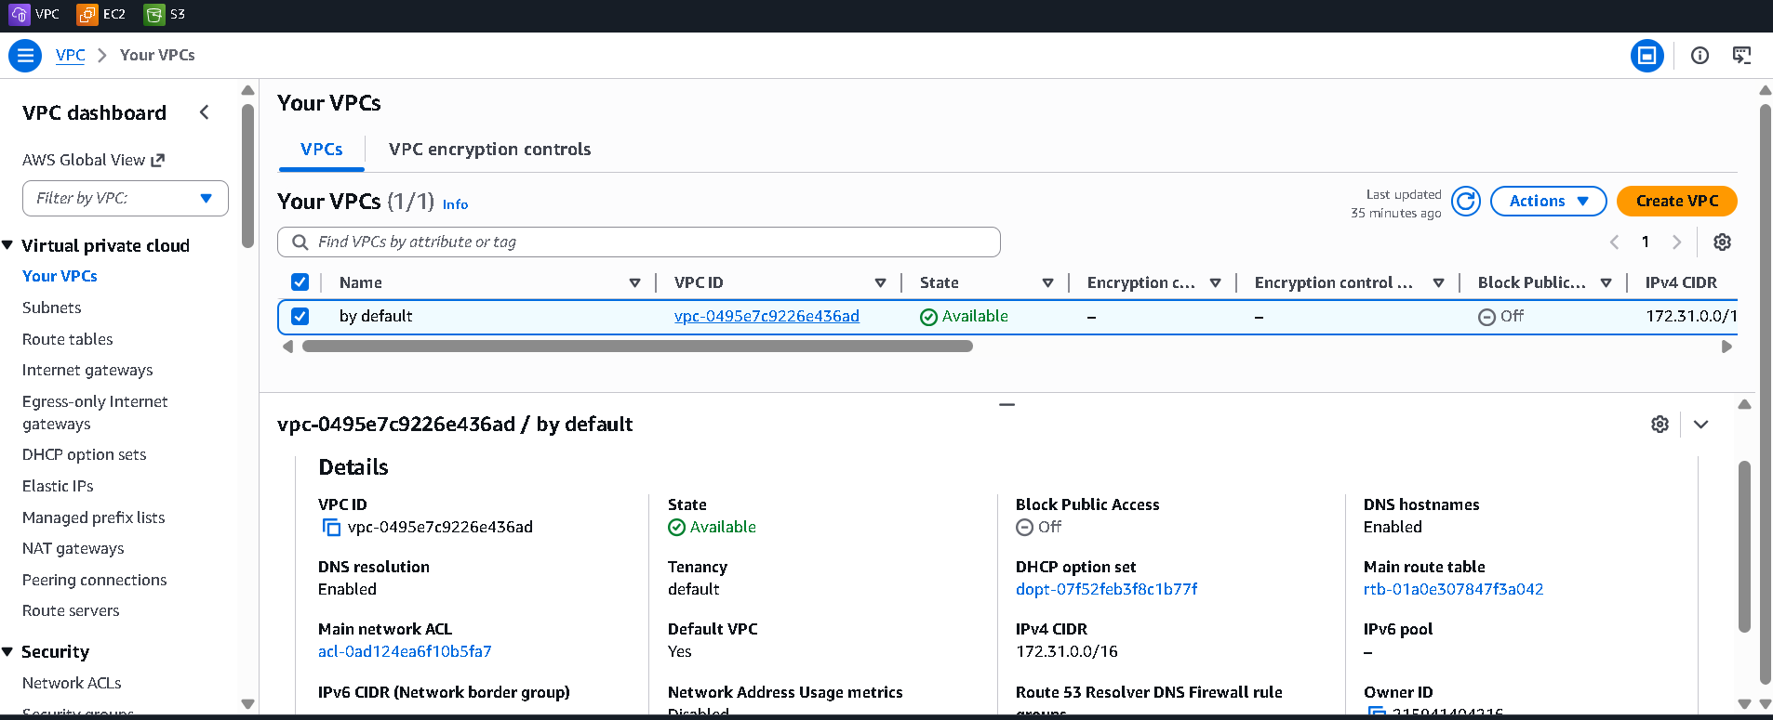
After that, I created a Virtual Private Gateway and connected it again.
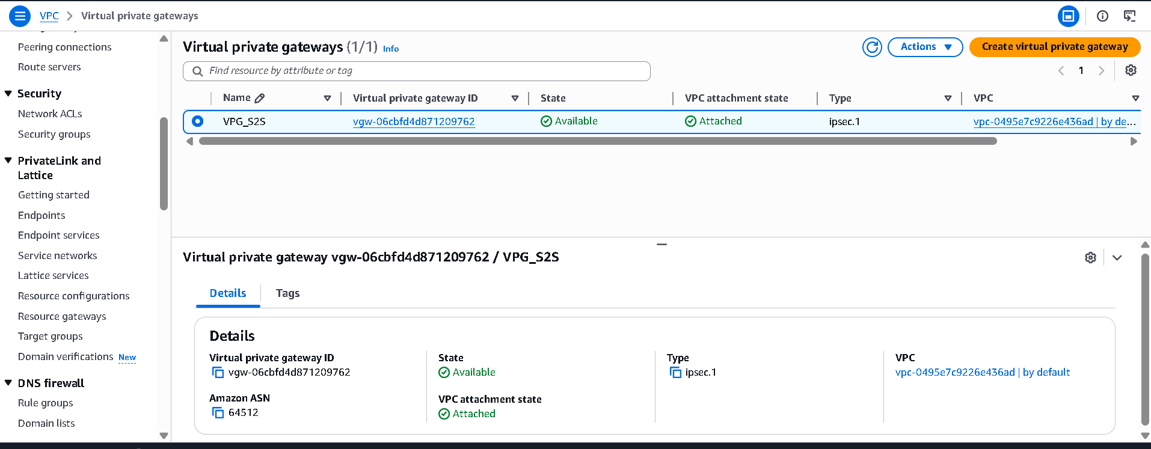
After that, I created a customer gateway.
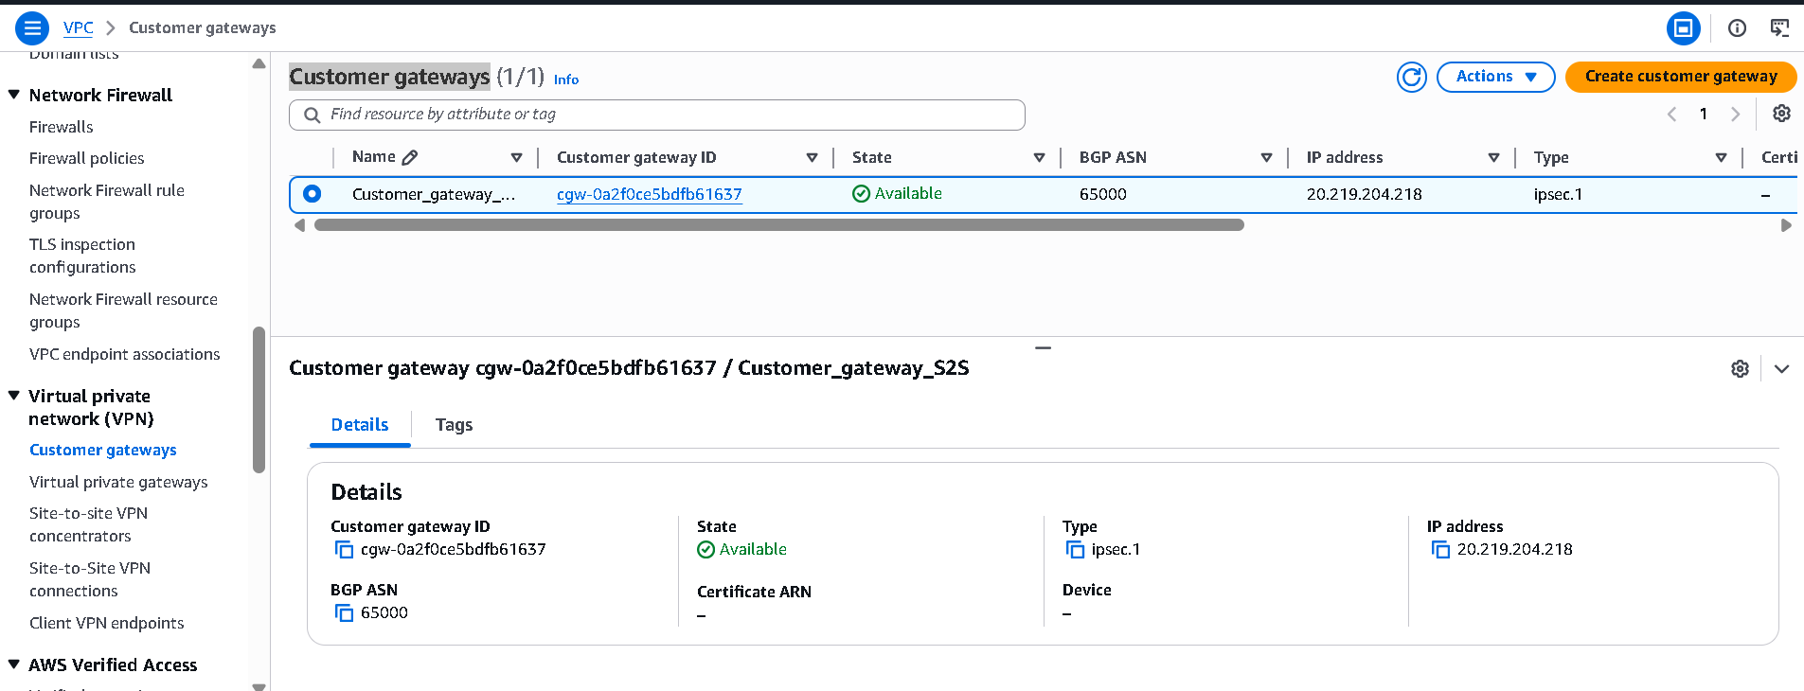
Note : The IP address here belongs to my Azure Virtual Network Gateway.

After that, I set up a site-to-site VPN connection.
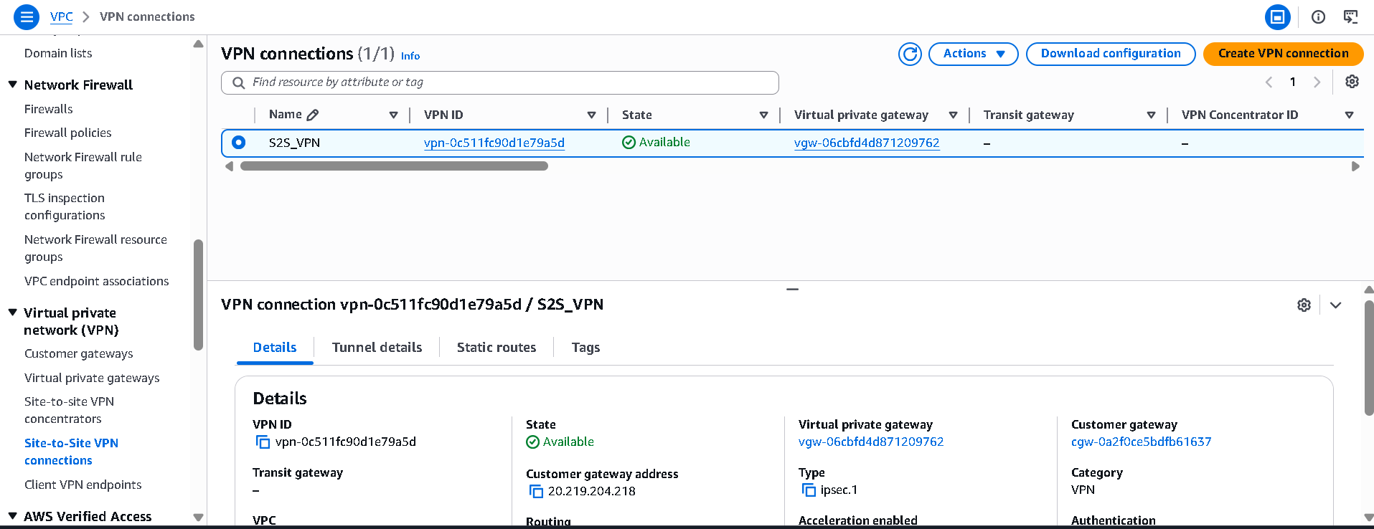
Note : In the local IPv4 network settings, I specified the range for my Azure VNet.
After that, AWS created two tunnels for me.
Which is visible below.
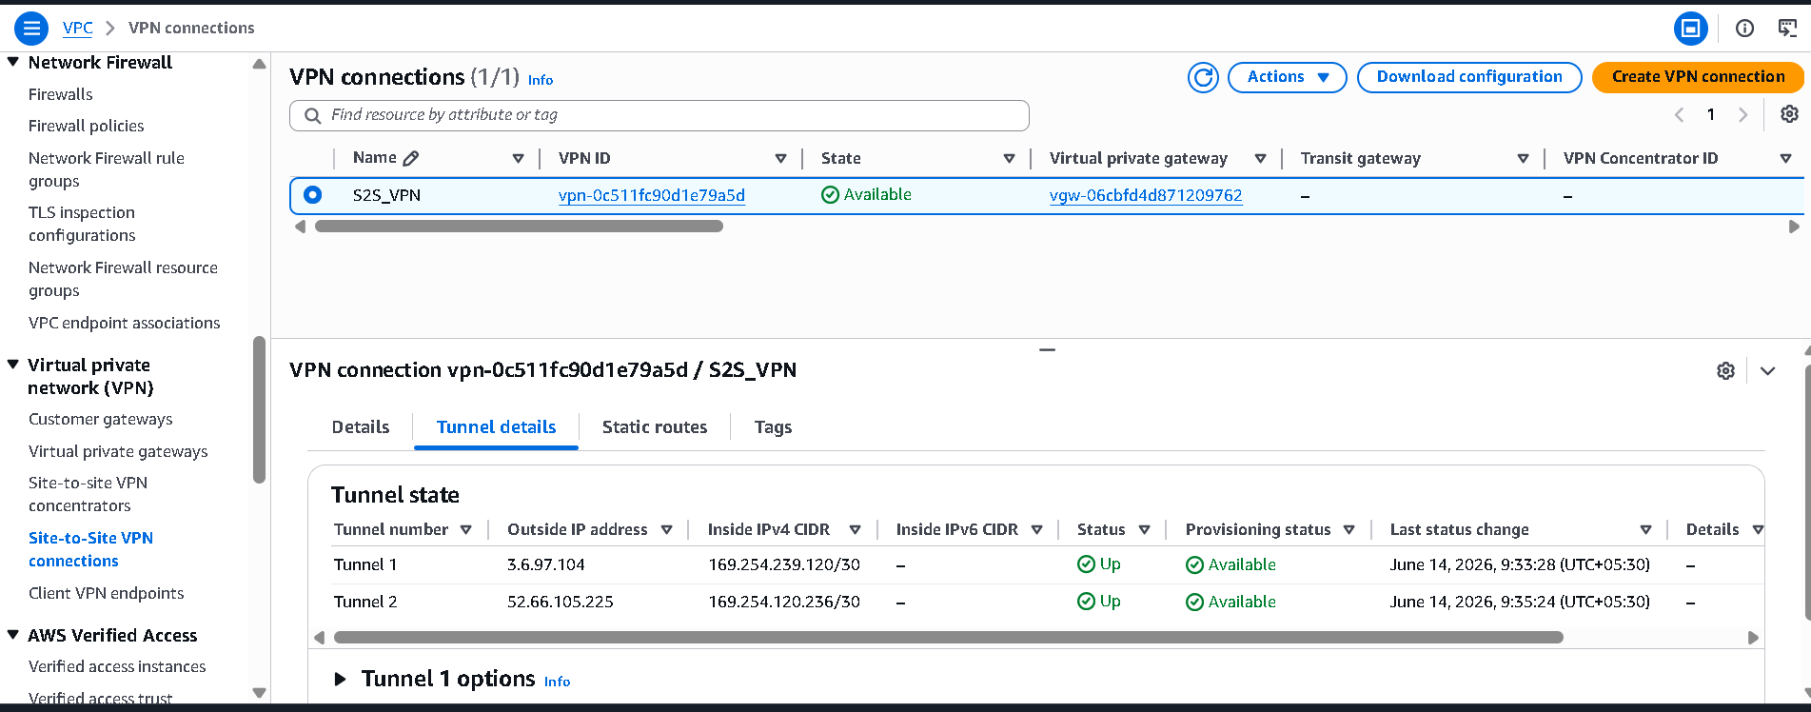
After that, I created two local network gateways on Azure.
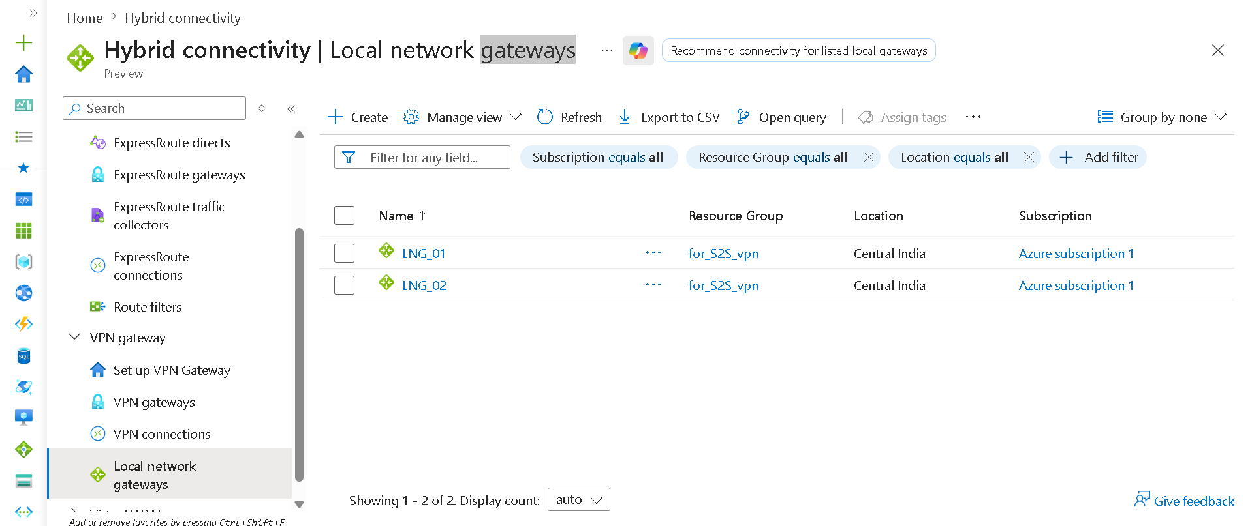
Details of LNG-01
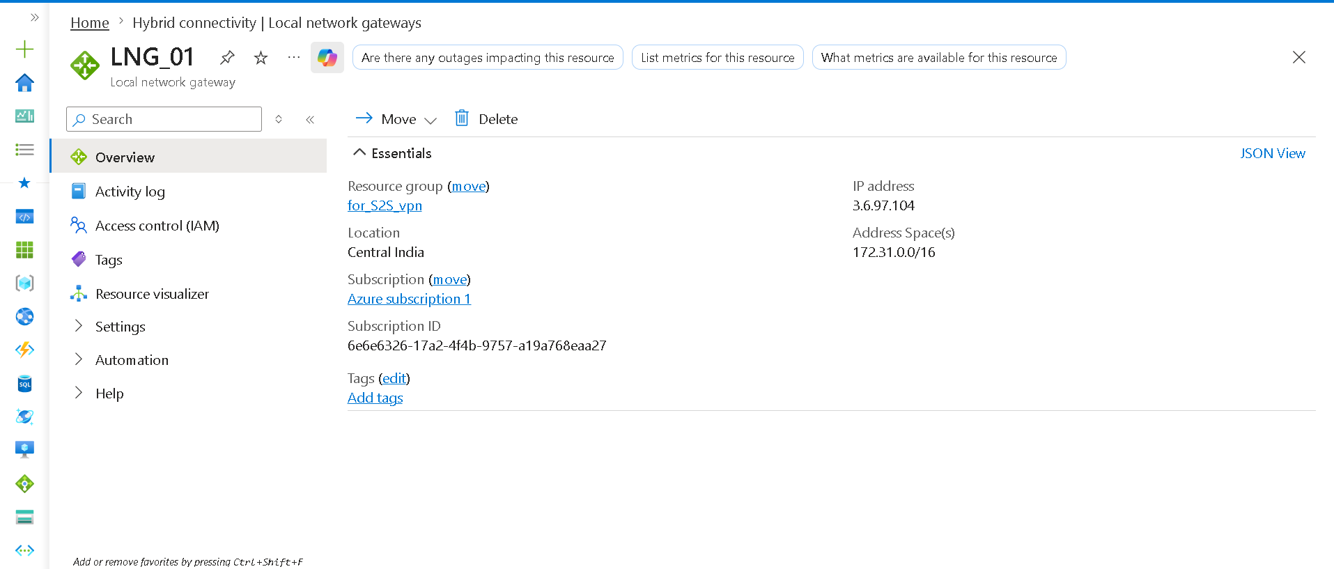
Note: The IP included here belongs to my AWS Tunnel 1. Or The range shown in this is the range of my AWS VPC.
“I did the same thing for Lang-02 that I did for Lang-01.”

After that, I created two connections in the virtual network gateway.
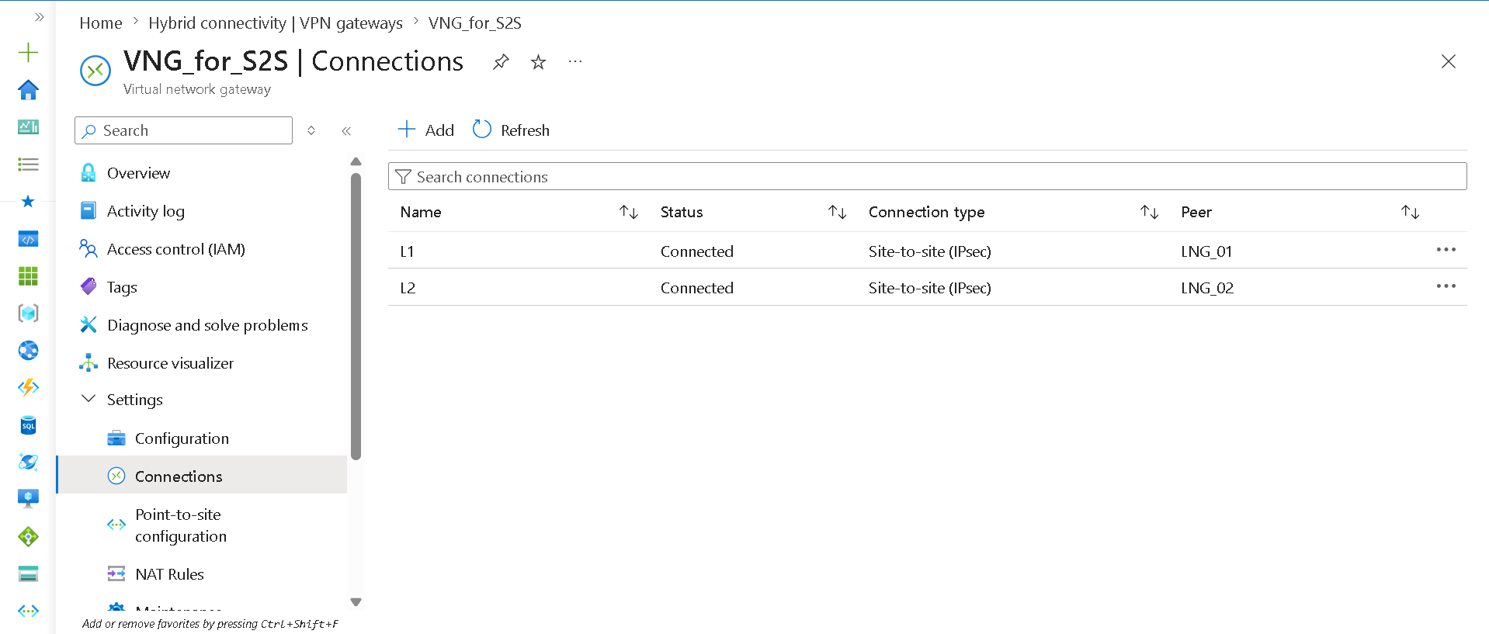
Note : After that, check whether Tunnel 1 and Tunnel 2 are up or not.
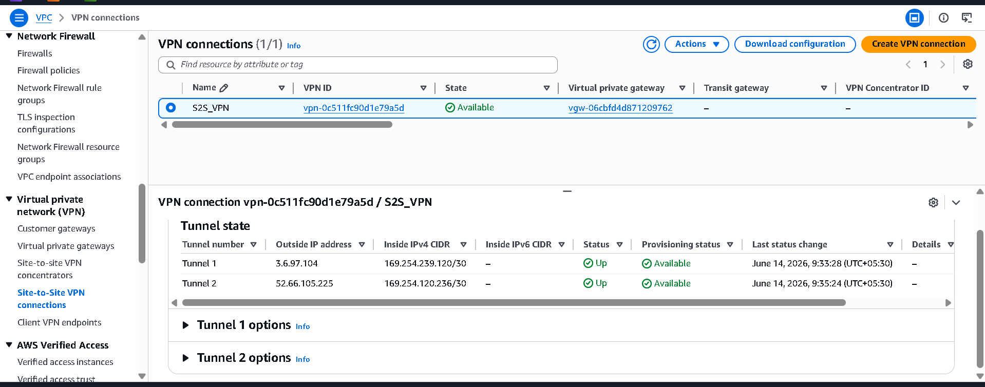
connections is ok

Created a VM in Azure and ping the IP of the AWS EC2 instance.
